EXPERIMENT 2

ER DIAGRAM FOR SAILOR BOAT DATABASE

**Aim:** Draw an ER diagram of sailor database.

**Components of an ER Diagram**:

Entity: Object that is relevant to given system. Represented as rectangle.

Attribute: Trait of an entity, relationship or other attribute. Represented as oval.

Relationship: Describes how entities interact. Represented as rhombus.

Primary key: The key which will uniquely identify and associate identify for an entity.

Cardinality: The number of entities that can participate in a relationship with another entity set.

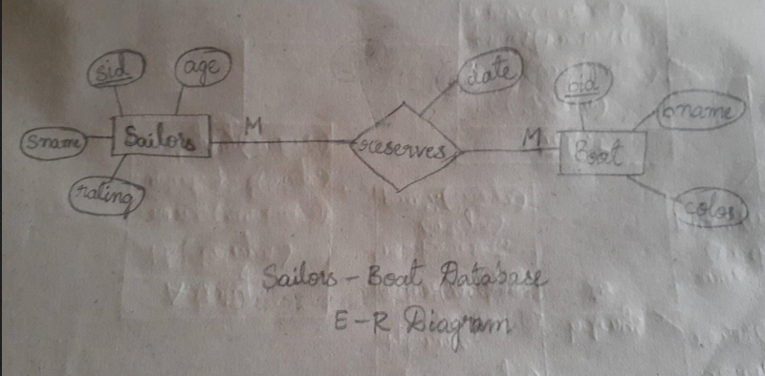

**ER Diagram:**

